**1.4 video**

**Name:**

**Date:**

**Time overhead:**

1. Please explain the following terms:
   1. Intraframe compression: 将单帧图像中的相同或相似像素用一种统一的形式存储，从而对视频所需存储空间进行压缩。
   2. Multimedia container formats
   3. Temporal redundancy
   4. Frame rate
   5. Spatial redundancy
   6. lnterframe coding
   7. Explain the interlaced encoding and progressive encoding
2. (a) Name the video terms described below:

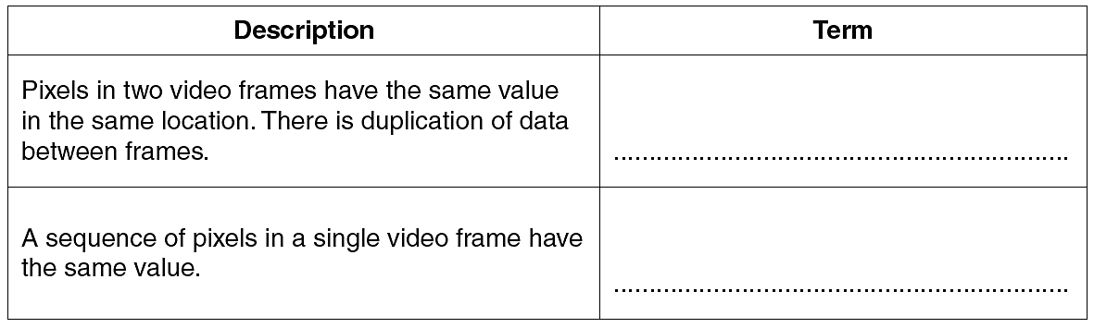

(b) Give **one** file technique that could be applied when either of the two features described in **part (a)** are present.